East Bound / Au tour de l’Atlantique
This unique conference for book professionals from Atlantic Canada and beyond will be held at the Sheraton Hotel Newfoundland from June 5-7, 2019. Unique in the country, East Bound is established as a venue for opinion leaders working in book publishing, libraries, bookstores, schools and universities, and the media. This year, East Bound will be held in St. John’s, Newfoundland. This year’s conference will take place alongside the Atlantic Book Awards and the Atlantic Provinces Library Association conference, creating greater opportunities for networking and a bigger book buzz.
The 2019 East Bound conference will spotlight innovative solutions that create a greater awareness and readership of local, regional and Canadian books among readers and the wider public. The theme “Building Communities” focuses this conference on initiatives, policies and programs that will develop greater synergies among bookstores, public libraries, book media and publishers in communities large and small. Inclusion is key to the work of the APMA, and the conference will be designed to engage publishers and book professionals throughout the region in both languages. It will focus on success stories from across Canada and beyond.

About the Atlantic Publishers Marketing Association
The mission of the Atlantic Publishers Marketing Association is to support the writing and publishing of books in Atlantic Canada. Our mandate is to act as a trade association for publishing houses and to carry out joint promotion and marketing activities to support and expand the sales of books published by our members across the Atlantic Provinces, and across Canada and internationally. The publishers in Atlantic Canada believe a vigorous Atlantic-owned-and-controlled book publishing industry is essential to the economic, cultural, educational and social life of Atlantic Canada. It currently undertakes marketing activities to support the publishing and sale of well over 100 new trade books annually.
Our activities include support for ongoing collaboration among our member publishers in working together to represent the interests of writers and publishers, and more importantly to undertake a diverse range of traditional and digital marketing activities and to provide professional development opportunities for publishing company staff and publishing professionals. We engage in collective marketing ventures designed to raise awareness of and to increase market share for Atlantic Canadian books among readers and book-buyers in Atlantic Canada, including our regularly published Atlantic Books Today magazine and the Book Lovers’ Holiday Gift Guide, distributed throughout Atlantic Canada in newspapers, bookstores, libraries and cafes. We also create online content, marketing, and bookselling through the AtlanticBooksToday.ca website and the Atlantic Books Today social-media and E-newsletter marketing campaigns.

DRAFT PROGRAM - SUBJECT TO CHANGE

WEDNESDAY JUNE 5

10:30 am - 1:00 pm
APMA Executive Committee Meeting

12 :00 – 1:30 pm
Registration and welcome for delegates and publishers

1:30 - 5:00 pm
APMA Annual General Meeting
7:00 pm
Breakwater’s Spring Launch Party and Welcome Reception
Johnson GEO Centre

10:00 pm
Drinkcussions
BIVVER Lounge, Sheraton Hotel

THURSDAY JUNE 6
8:15 - 9:15 am
Keynote address
9:45 - 10:45 am
Creating Awareness of Canadian Books Among Canadian Readers: The Role of the Media

10:45 - 11:45 am
Innovations in the Publishing Model: Old-World Models, New-World Thinking
12:00 - 1:00pm
Atlantic Publishing: New Faces | Lunch and Learn

1:30 - 2:30 pm
Co-hosted by APLA
By the Numbers: Up-to-date research from BookNet Canada and Research Design House on Reading Habits, Library Collections, Borrowing, and Buying

2:30 - 3:30 pm
Co-hosted by APLA
Innovative Partnerships: Libraries, Bookstores and Media Panel on NL Reads

4:00 - 5:00 pm
Co-hosted by APLA
Canadian Content in Canadian Libraries: Demand-driven Content or Content-driven Demand
7:00 pm Atlantic Book Awards

10:00 pm Drinkcussions
BIVVER Lounge, Sheraton Hotel

FRIDAY JUNE 7

8:15 – 9:15 am
Breaking through the Noise: How to Increase the Canadian Presence for Books in a Digital World: Case studies in other media

9:15 -10:15 am
Bookstores as Community Builders: Case Studies

10:30 – 11:30 am
Public libraries and independent bookstores: Capturing Synergies

Pre-scheduled one-on-ones between publishers and delegates take place throughout the morning at the Sheraton Hotel Newfoundland

11:45 am
Lunch Arounds
1:45 –2:45 pm
New policies and programs to increase awareness and reading of Canadian books: Assessing/adding to the More Canada report proposals

2:45 – 3:45 pm
Breakout sessions to discuss policy and program ideas

3:45 – 5:00 pm
Plenary Session: Visions for the Future – Reports from the breakout sessions and reactions and comments from policy makers

ABOUT ST. JOHN’S
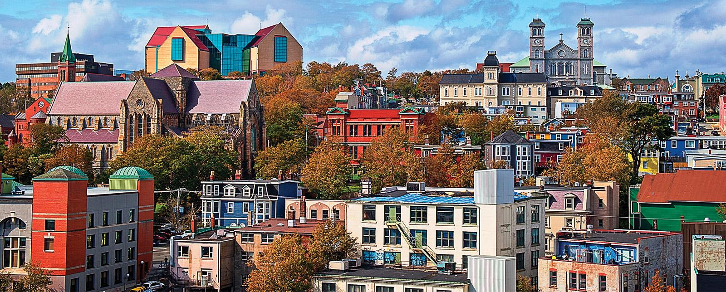
Rich and colourful, rugged and refined, St. John’s is the creative capital, and the beating cultural heart of the province. With 500 years of history and tradition woven into our fabric, you’ll also find a new wave of art, architecture, music, and cuisine. Take a guided tour of the colourful cityscape, visit a historic site, gallery, or museum. As the most easterly city in North America, there’s always a pretty impressive ocean view.
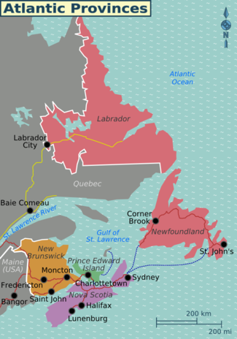
Unwind after a day of exploring the colourful neighbourhoods of St. John’s and get ready to tap your toes to fiddles and mandolins in one of the city’s many live music venues. Generations of influence from Ireland and the British Isles make St. John’s no stranger to pubs, pints, and laughs. Fancy something different? As home to one of North America’s premier entertainment districts, we have every variety of nightlife, enjoyed by a genuine mix of locals and visitors alike.

GETTING HERE
You can fly on one of the many carriers that fly direct into St. John’s from Halifax, including: Air Canada, Porter Airlines, PAL Airlines and WestJet. To check for the best available rates that match your travel preferences, we recommend using a site such as kayak.ca that can compare multi-airlines and variables.

ACCOMMODATIONS
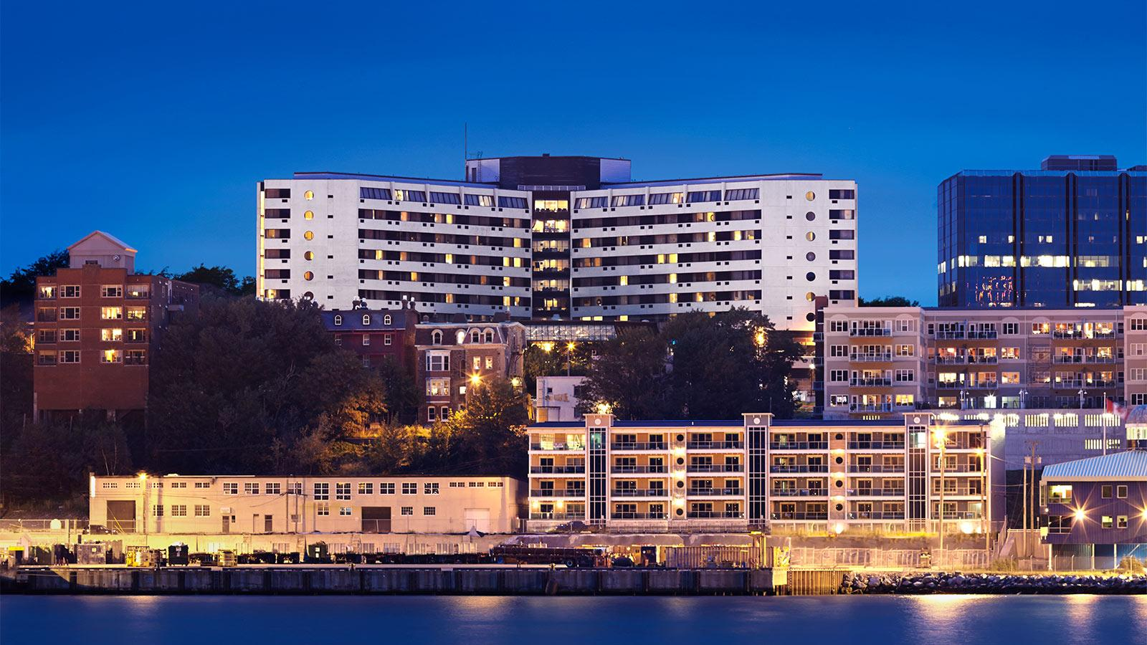
The Sheraton Hotel Newfoundland is a landmark hotel located in historic downtown overlooking St. John’s harbour and Signal Hill. Steps away from shopping, restaurants, museums and nightlife. Enjoy luxurious guestrooms, the BIVVER lounge, all-day restaurant, health club, pool/saunas, lush Court Garden, on-site spa and high speed Internet access.

A limited amount of rooms have been set aside for East Bound attendees, available on a first-come, first-served basis. High occupancy rates are expected in St. John’s in early June due to several other concurrent conferences happening at the same time as East Bound. We encourage all attendees to make their reservations ASAP – all rooms not booked will have to be released on May 4, 2019.

Reservations can be made directly by calling toll free at 1-888-870-3033 or through e-mail at reservations@sheratonhotelnewfoundland.com. Hotel Reservations is open Monday – Friday, 9:00 am – 5:00 pm Newfoundland Standard Time. Please identify yourself as a member of APMA Atlantic Publishers Marketing Association East Bound June 2019 in order to qualify for the special conference rate of $189 per night for a standard double room.

TRAVEL SUBSIDIES

APMA is pleased to offer a limited amount of travel subsidies to our Active and Associate members travelling to East Bound and the APMA Annual General Meeting from out-of-area.
To be eligible for travel subsidy, members must participate in both days of East Bound 2019.

Travel subsidies cover:
- 50% of the lowest economy airfare from your home airport (net of HST)
- 50% of two nights’ accommodation, up to a maximum of $189 per night (net of HST), for those attending both East Bound and the APMA AGM. Otherwise, you will be limited to one night’s reimbursement.
- 50% of mileage (0.42 per km) for those who live beyond the normal commuting distance

Meals and other incidentals are not eligible for reimbursement.

Subsidy funding is limited. Travel subsidies will initially be limited to one member per firm. Firms that wish to apply for a second subsidy may do so, and will be put on a waiting list. If funds permit, subsidy funds will be awarded to additional registrants on a first-come, first-served basis.

Claims will be reimbursed following East Bound upon submission of receipts and the completion of subsidy claim and evaluation forms, due no later than July 21, 2019. Claim forms will be distributed with your registration package.

ACP SUBSIDIES

Did you know that East Bound 2019 qualifies under the Association of Canadian Publishers Professional Development subsidy program? Visit http://publishers.ca/pd-subsidy/

REGISTRATION FORM

Name (as you would like it to appear on your name tag): _____________________________________________
Job Title: ________________________________________________________________________________________________________
Business or Affiliation: _______________________________________________________________________________________
Email: ____________________________________________________________________________________________________________
Office Phone: _____________________________________ Mobile phone: _________________________________________
Street Address: _________________________________________________________________________________________________
City/Town: __________________________________________ Prov: _______________ Postal Code: ____________________
Conference Registration Options
- Early Bird APMA Member - $175+ 15% HST (per person, available until May 3, 5pm NST)
- Early Bird Non-Member - $200+15% HST (per person, available until May 3, 5pm NST)
- APMA Member - $225+15% HST (per person, available until May 31, 5pm NST)
- Non-Member - $250+15% HST (per person, available until May 31, 5pm NST)
Registration includes coffee and snack breaks June 5-7, lunch on Thursday June 6, transportation to Thursday afternoon sessions and Friday lunch arounds, and admission to all sessions June 5-7.
Please note: registrations are transferable but non-refundable after May 17, 2019.
Atlantic Book Awards Ticket(s)
Thursday June 6 at 7pm at the Emera Innovation Exchange. Tickets are $20 (no tax)
- $20 per person x _______ (quantity) = $ ____________
Method of Payment:
- Cheque payable to Atlantic Publishers Marketing Association (enclosed)
- E-Transfer to accounting@atlanticpublishers.ca with password “APMA”

Do you require any special physical or dietary accommodations? If yes, please specify.
________________________________________________________________________________________________________________

Gender pronoun preference:
He/him/his She/her/hers They/them/theirs Other
APMA Member firms:
Are you the voting delegate* for your firm Yes No
* Note: Only firms that hold Active membership in the APMA may vote at the meeting with one vote per firm. Only members in good standing may vote at the meeting.

Completed forms may be sent:

By e-mail:
admin@atlanticpublishers.ca

By post:
APMA - 1888 Brunswick St.
Suite 710, Halifax, NS B3J 3J8

